Transit Gateway

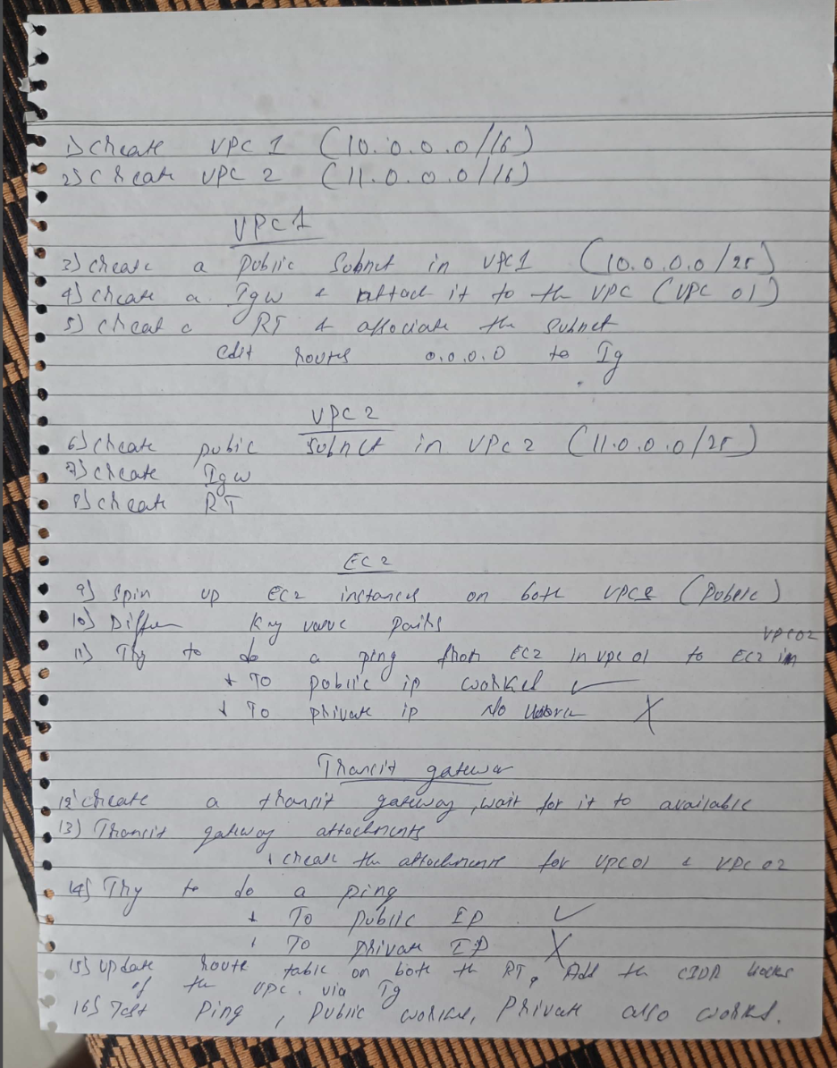

If we want to connect VPC to the same transit gateway we can use RAM. The limitation here is we can share the resource within the same regions

If we want to connect multiple VPC from different regions, then we need to do the Transit gateway peering

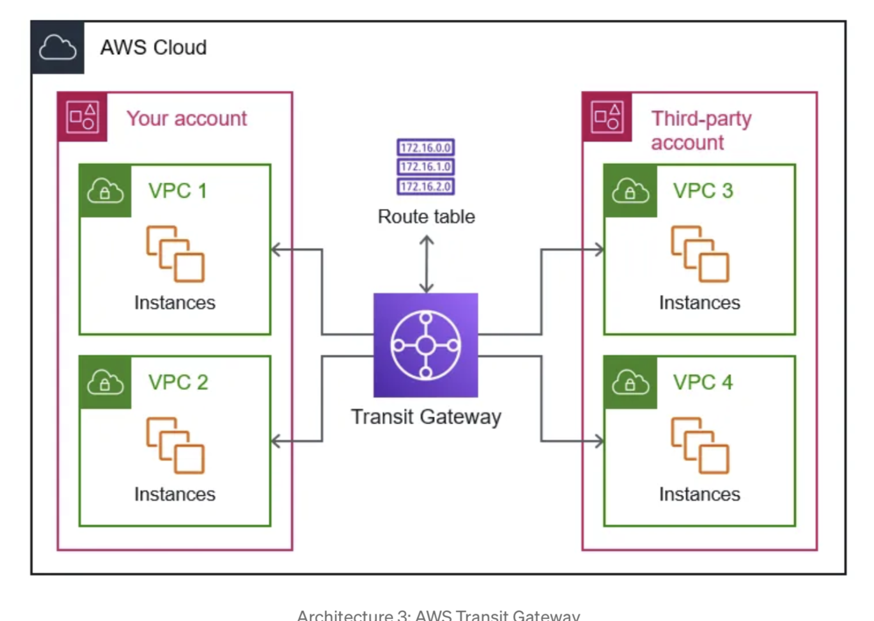

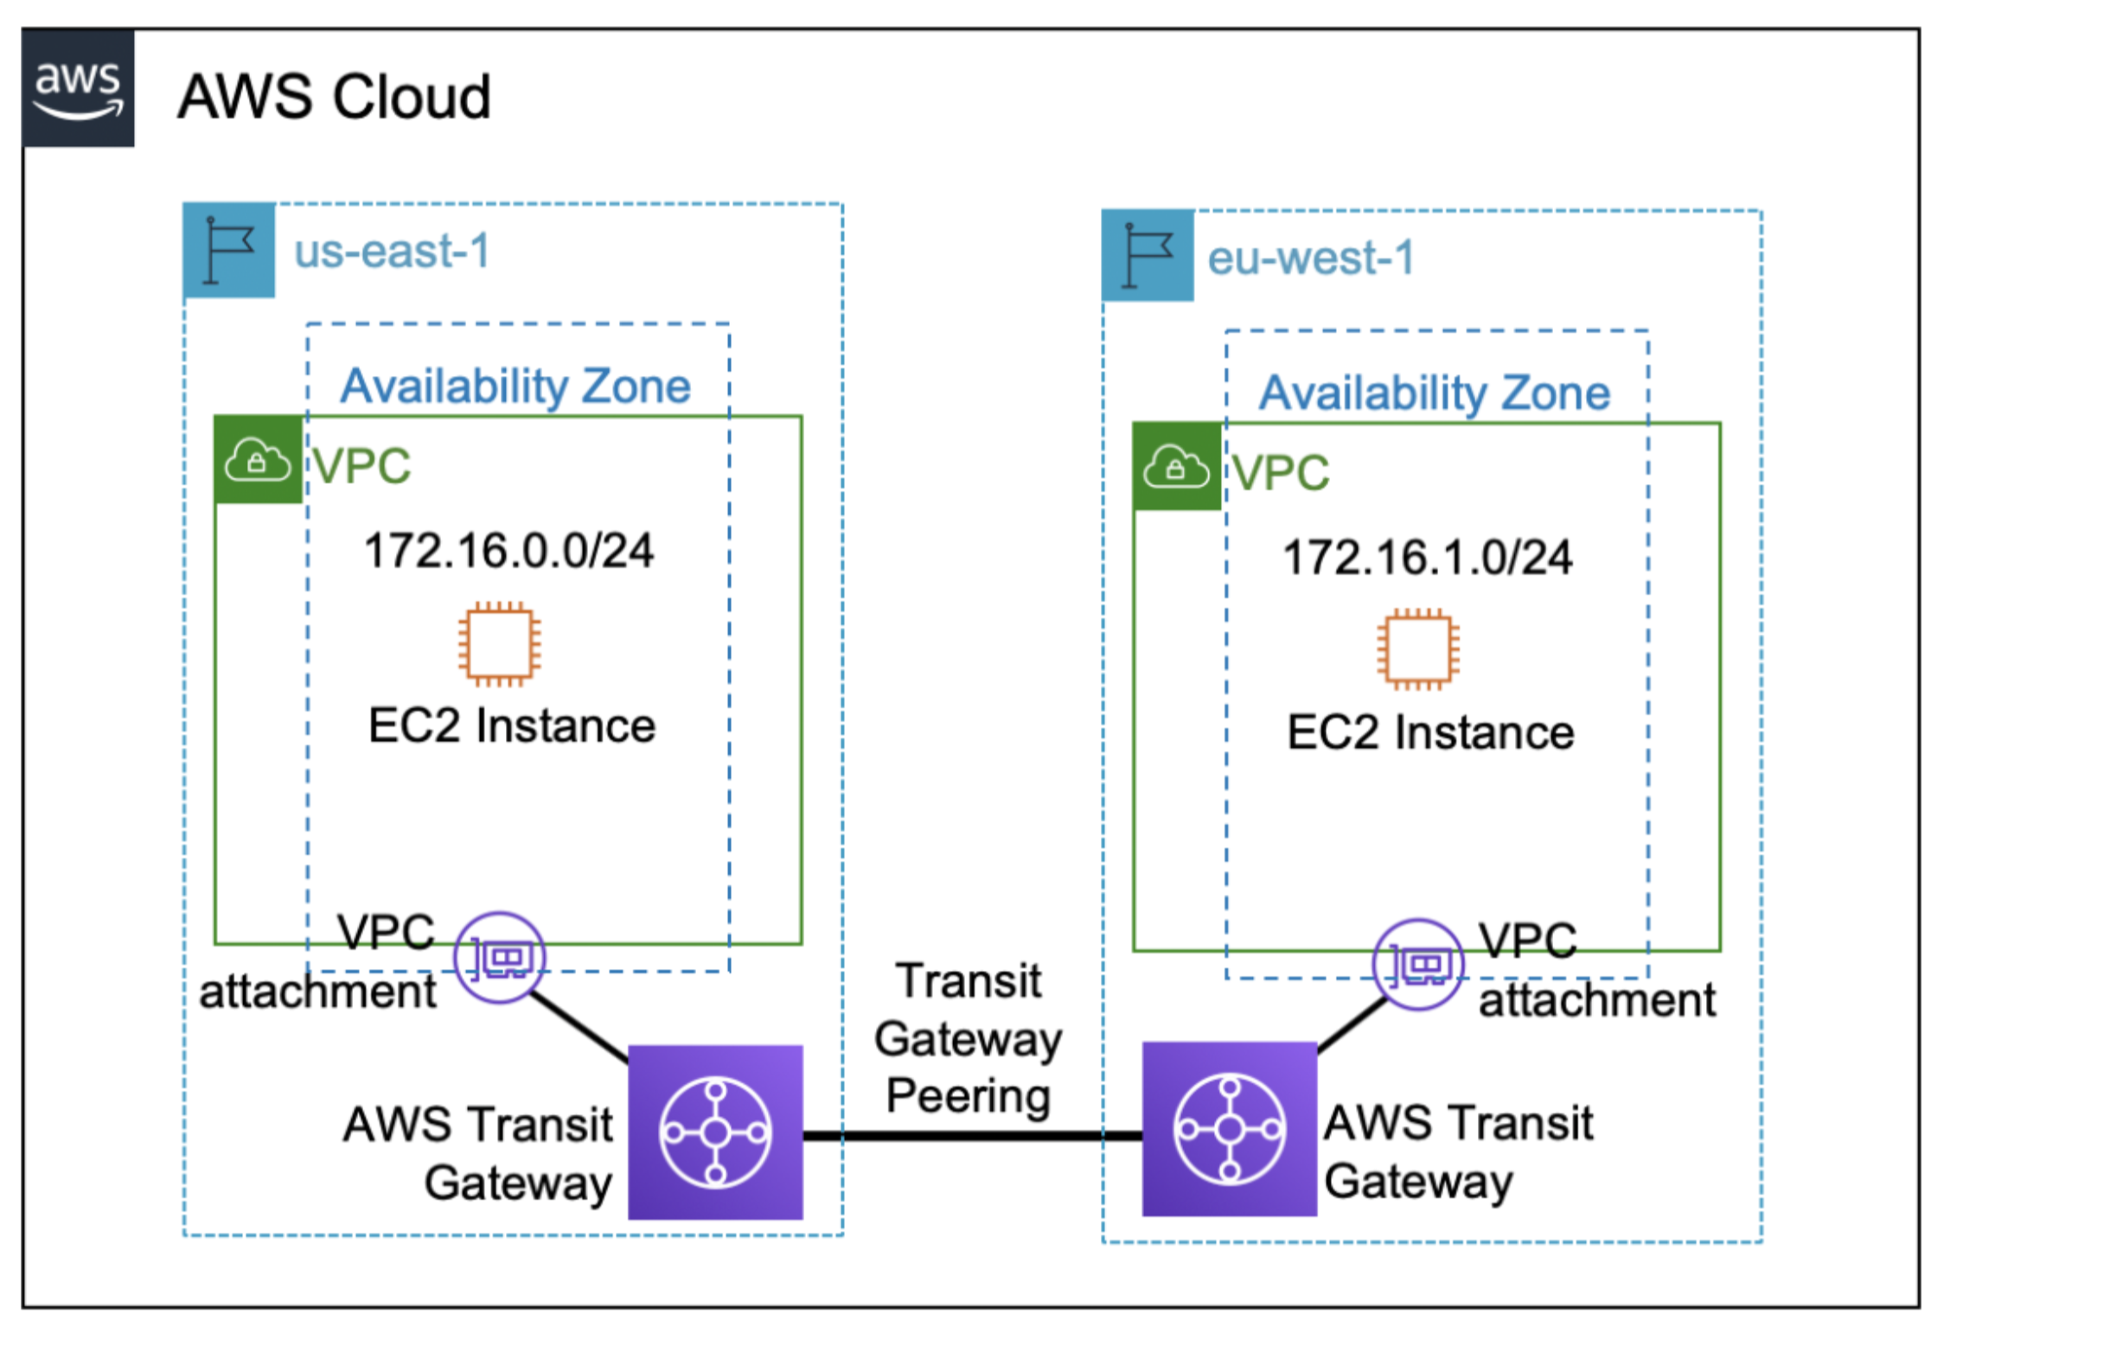

If we are doing Transit peering, we need to update the transit route table.